Stata Assignment 5
Sarah Pickersgill
PART 1
We wish to evaluate the association between vigorous physical activity (exposure) and poor mental health in the past month (outcome) in Washington State. In order to evaluate this, we will use the 2017 BRFSS dataset, which is a national annual health survey (see survey lecture notes and page 109 in the course packet for the Stata programming used to import BRFSS data and setting survey weights). Create a new do file that replicates the commands needed to answer the following questions. Turn in the do file as well as answers or output corresponding to those items that are bolded below.
Import the 2017 BRFSS Data file into Stata. Set survey weights and restrict data file to respondents from Washington State (state==53). Because you are only analyzing data from Washington State, do not specify a stratum variable in your survey weights (Code: svyset _psu [pweight=_llcpwt]). Use the calculated variable codebook to identify our exposure (pa1vigm_) and outcome (_ment14d) of interest. Use codebook to convert don’t know/refused/missing values to the appropriate missing values (.) and label the following variables and their corresponding values (Hint: A do file posted with homework 5 contains code for creating variable & value labels.):

_race : Non-Hispanic race & Hispanic ethnicity
_age_g : Age groups
_incomeg : Income groups
_educag : Education attainment
_rfsmok3 : Current cigarette smokers
_curecig : Current e-cig users
_pacat1 : Physical activity groups
pa1vigm_ : Minutes of vigorous physical activity per week
_ment14d : Mental health status

Save your new data set with the nine variables listed above and restricted to Washington State respondents. Summarize the new data set.
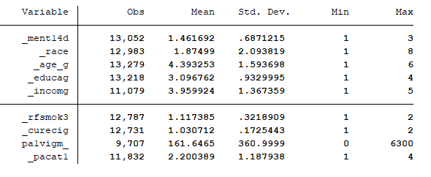

- Describe mental health status (_ment14d) by physical activity groups (_pacat1). Be sure to include the weighted prevalence and unweighted count of survey respondents (or observations) for each response in your table. Then compare the mean number of minutes of vigorous physical activity (pa1vigm_) for adults with zero poor mental health days vs. adults with at least 14 poor mental health days (hint: use svy: mean command). Include output and summarize results (mean and 95% CIs). Do you think mental health days are associated with vigorous physical activity?

 | Mental health status (days when mental health not good)
Physical activity |  | Zero days | 1-13 days | 14+ days
Highly active | Weighted prevalence: | 63.93%  [62.01 , 65.81] | 25.37%  [23.68 , 27.14] | 10.7%  [9.47 , 12.06]
 | Unweighted counts: | 3312 | 1071 | 413
Active | Weighted prevalence: | 63.05%  [60.42 , 65.62] | 27.41%  [25.09 , 29.85] | 9.54%  [8.02 , 11.3]
 | Unweighted counts: | 1460 | 589 | 204
Insufficiently active | Weighted prevalence: | 56.73% [53.98,59.44] | 30.93% [28.43,33.56] | 12.34% [10.67,14.23]
 | Unweighted counts: | 1260 | 607 | 254
Inactive | Weighted prevalence: | 57.69% [55.03,60.31] | 23.21% [20.97,25.6] | 19.1% [17.13,21.24]
 | Unweighted counts: | 1485 | 549 | 446

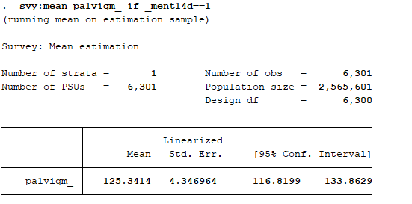
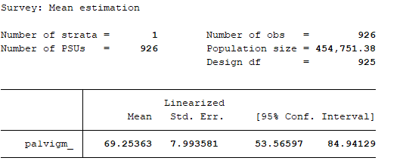
The mean number of minutes of vigorous physical activity for adults with zero days of poor mental health day is 125.34 [116.82, 133.86]

The mean number of minutes of vigorous physical activity for adults with at least 14 days of poor mental health day is 69.25 [53.56, 84.94]

From this information, there appears to be an association between vigorous physical activity and mental health. To understand the relationship better I would want to do some hypothesis testing however.

- Prepare your dataset for analysis. Because we are interested in the binary outcome of poor mental health, recode _ment14d so that all adults who reported at least 14 days of poor mental health = 1; adults who reported fewer or no poor mental health days = 0; and adults not asked the question/refused/unknown = missing (.).

Similarly, we are interested in creating a binary vigorous activity variable. Create a new variable that recodes adults who did any vigorous exercise = 1; adults who did no vigorous exercise=0.

Obtain the crude risk estimate for the association between poor mental health and vigorous exercise (any vs. none) (hint use svy: logit command). In writing, justify your choice of the measure of association (odds ratio or relative risk). Also, include a 2x2 table (use svy: tab) and the output which you used to determine your answer.

In this analysis I am looking at the odds ratio, since logistic regression is the kind of regression you use when you have a binary outcome.

The crude odds ratio for the association between poor mental health and vigorous exercise is 0.57 [0.47 , 0.69]. Meaning, the odds of poor mental health are 43% lower for those who engage in some vigorous exercise compared to those who engage in zero vigorous activity. See tables below.
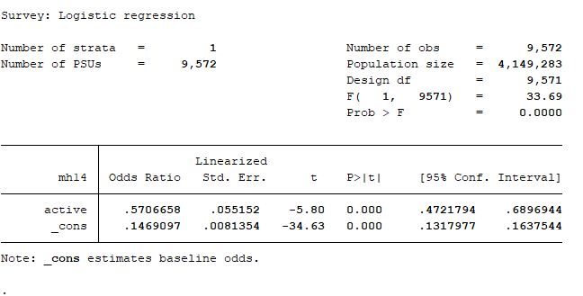
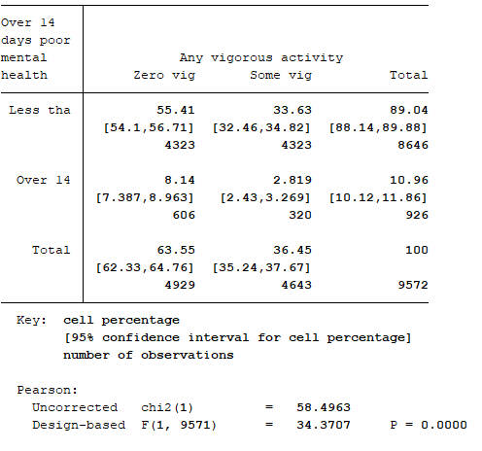

- Assume that you have already determined that there is no effect modification in this dataset. Determine whether there is confounding by any of the measured variables (race, age, income, education, cigarette and e-cig use) in the association(s) between poor mental health and vigorous exercise. Create a table that includes the crude and adjusted risk estimates (one variable at a time) for each of the six covariates listed above, highlighting any confounders you have identified.

Potential confounder being adjusted for: | Odds ratio (adjusted risk estimate) | Confidence interval | p-value | % different than crude
Crude | 0.5707 | .4721794 , .6896944 | <0.0001 | 0%
Race | 0.5578 | .4569132 , .6810528 | <0.0001 | -2.26%
Age | 0.7643 | .6097537 , .9581187 | 0.020 | 33.9%
Income | 0.6233 | .5065516 , .7668878 | <0.0001 | 9.22%
education | 0.6253 | .5171112 , .7560602 | <0.0001 | 9.57%
Cigarette use | 0.6147 | .5077542 , .744222 | <0.0001 | 7.71%
E-cig use | 0.6170 | .5098865 ,.7465771 | <0.0001 | 8.11%

By the 10% rule, the only confounder in this analysis is age (although many like income and education are quite close to the 10% cut-off).

- If you identified more than one confounder, determine the risk estimate adjusted for all identified confounders simultaneously. Include your output and interpret the adjusted risk estimate. How much did your sample size reduce by including all potential confounders in analysis?

To address this question properly, I will include age, income, and education as confounders for this analysis.

By including these three confounder, my sample size is now only 8,239 observations (compared to 9,572 observations in the crude analysis). This is a decrease of 1,333 observations.

See output below.
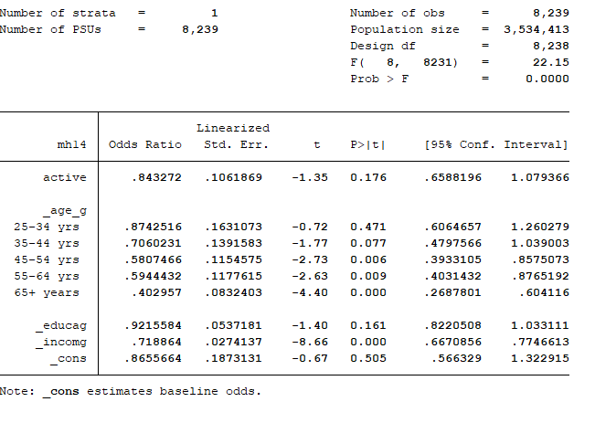

PART 2

Using the same data set, determine the association between minutes of vigorous physical activity per week and educational attainment. For this analysis, minutes of vigorous physical activity (continuous) will be the dependent variable and categorical educational attainment will be the independent variable. Turn in answers or output corresponding to the items that are bolded below. You do not need to turn in a do file for this part of the assignment.

- Create a 3-level categorical variable where 0=did not graduate high school, 1=high school graduate or some technical/college education, and 2=graduated college or technical school. Label the new variable and its values. Include a one-way frequency table for this new variable.
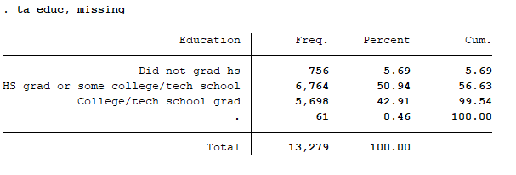

- Use linear regression to determine the association between educational attainment and minutes of vigorous exercise. (Hint: You will need to tell Stata to create indicator variables for educational attainment.) Provide beta coefficients (and 95% confidence intervals) comparing adults who graduated high school/some college to adults who did not finish high school; adults who graduated college to did not finish high school; and adults who graduated college to graduated high school/some college. Include your output and interpret the results.

Ehat[vigorous activity | education] = B₀ + B₁(educ1) + B₂(educ2)

Where:
educ1 = 1 if HS grad or some level of college/tech school and 0 otherwise
educ2 = 1 if college/tech school graduate and 0 otherwise
B₀ is therefore the vigorous activity for education less than HS (zero for both educ1 and educ2)

B₀ = 100.9 mins [66.01266 , 135.8414]
B₁ = 62.5 mins [26.07485 98.93247]
B₂ = 64.6 mins [28.17403 101.0304]

So, on average;
- The estimated mean vigorous activity time for those who did not graduate high school is 100.9 minutes.
- The estimated mean vigorous activity time for those who graduated high school or attended some level of college/tech school is 163.4 minutes.
- The estimated mean vigorous activity time for those who graduated college/tech school is 228 minutes.

See output below.

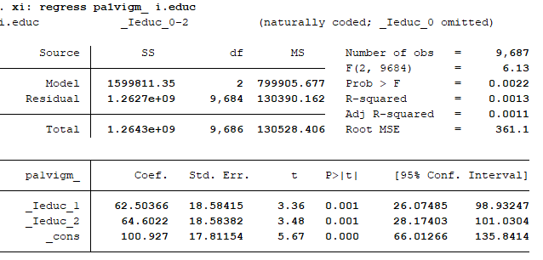
‘

- What duration of vigorous exercise does the model predict for adults who did not graduate high school?
- On average, the estimated mean vigorous activity time for those who did not graduate high school is 100.9 minutes.

PART 3

We will use the dataset classlist2019.csv (a comma-delimited Excel file) to practice manipulating string variables. The dataset can be found in the downloads section of the course website. Turn in answers or output corresponding to the items that are bolded below. You do not need to turn in a do file for this part of the assignment.

- Import the Excel file classlist2019.csv into Stata. Create a numeric variable for department (epidemiology, non-epidemiology). Label the values of this variable. Use tabulate to obtain the frequency of this newly created variable.
** Assuming those in programmes like “Epidemiology: Clinical Research” are still in the epidemiology department and are therefore coded as 1 for my analysis.

import delimited using classlist2019.csv
list
drop in 1/1

gen deptt =.
replace deptt=1 if strpos(v2, "Epidemiology")
recode deptt . = 0

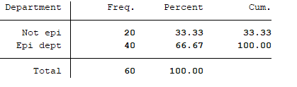

- Create a numeric variable called “emailk” that identifies which students have email addresses starting with the letter “k”. Label the values of this variable. Use tabulate to identify how many students have email addresses starting with the letter “k”.

gen str1 firstk = substr(v3, 1,1)

gen emailk=.
replace emailk=1 if firstk=="k"
recode emailk .=0

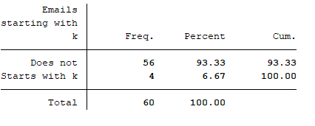

4 emails start with the letter “k”

- Create a string variable called “last3” that indicates the first 3 letters of a last name. How many students have the same first 3 letters in their last name?

gen str last3 = substr(v1, 1,3)
ta last3

There are 5 pairs of students who have the same first 3 letters in their last name (And, Bro, Cha, Kha, Rog)

Appendix – Parts 1&2

version 15

cd "C:\Users\Sarah\Epi510\Stata"
import sasxport LLCP2017.XPT
save brfss2017.dta

//Restrict data to WA state //
keep if _state==53

// Set survey weights //
svyset _psu [pweight=_llcpwt]

//label variables//
do Stata_hmwk5_labels.do

save brfss2017.dta, replace
clear

use _ment14d _race _age_g _educag _incomg _rfsmok3 _curecig pa1vigm_ _pacat1 _psu _llcpwt using brfss2017.dta

//recode variables for don’t know/refused/missing values to (.) //
recode _ment14d 9=.
recode _race 9=.
recode _educag 9=.
recode _incomg 9=.
recode _rfsmok3 9=.
recode _curecig 9=.
recode _pacat 9=.

//Describe mental health by activity level //
svy: tab _pacat1 _ment14d, row obs ci percent
svy:mean pa1vigm_ if _ment14d==1
svy:mean pa1vigm_ if _ment14d==3

//Prep data set .. create binary variables //
gen mh14 = .
replace mh14=0 if _ment14d==1 | _ment14d==2
replace mh14=1 if _ment14d==3

la var mh14 "Over 14 days poor mental health"
la def l_mh 1 "Over 14 days" 0 "Less than 14 days"
la val mh14 l_mh

gen active = .
replace active=0 if pa1vigm==0
replace active=1 if pa1vigm_>0 & pa1vigm~=.

la var active "Any vigorous activity"
la def l_active 1 "Some vigorous activity" 0 "Zero vigorous activity"
la val active l_active

// Crude risk estimate //
svy: logistic mh active
svy: tab mh active, obs percent ci

svy: tabodds mh active

//Checking for confounders //
svy: logistic mh active i._race
svy: logistic mh active i._age_g
svy: logistic mh active i._incomg
svy: logistic mh active i._educag
svy: logistic mh active i._rfsmok3
svy: logistic mh active i._curecig

//Adjusting for age, income, and education //

svy: logistic mh active i._age_g _educag _incomg

//Create education categorical variable //
gen educ =.
replace educ=0 if _educag==1
replace educ=1 if _educag==2 | _educag==3
replace educ=2 if _educag==4

la var educ "Education"
la def l_ed 0 "Did not grad hs" 1 "HS grad or some college/tech school" 2 "College/tech school grad"
la val educ l_ed

//linear regression for physical activity~education//
//xi: [regression command] [outcome] i.[predictor]//

xi: regress pa1vigm_ i.educ

